**Project Name - IndiaMart Clone**

Sunil Kumar

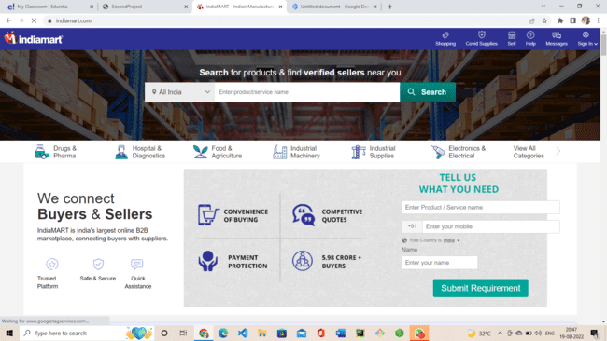

IndiaMart - Home Page

**Overview**

**IndiaMART InterMESH Ltd** is an Indian e-commerce company that provides B2B and customer to customer sales services via its web portal. The group began in 1996 when Dinesh Agarwal and Brijesh Agrawal founded the website IndiaMART.com, a business-to-business portal to connect Indian manufacturers with buyers. The company is headquartered in Noida. As of 2019, IndiaMART was the largest Indian e-commerce platform for businesses with about 60% market share, according to KPMG.

**Goals**

1. **Home Page**
2. **Login Page**
3. **Product Listing Page**
4. **Buyer Enquiry Page**
5. **Payment page**

**History**

IndiaMart was launched in 1996 as a directory of the websites for customers in the Delhi-NCR region by two cousins Dinesh Agarwal and Brijesh Agrawal.At that time India had only 15,000 internet users. By 1999, the directory had more than 1000 listings.

After overcoming the dot-com bust, in 2008–09 when the recession hit the US, the company decided to pivot the focus from export oriented business to India-focused B2B market and raised $10 million from Intel Capital in Series A round funding from Intel Capital, a part of which was invested in IndiaMART, One97 Communications and Global Talent Track.

In November 2014, IndiaMART started promotional campaigns featuring Indian film actor Irrfan Khan as its brand ambassador.

In March 2016, it raised Series C Funding from Amadeus Capital Partners and Quona Capital to scale up the activities of IndiaMART and Tolexo.

In 2016 and 2019, IndiaMART invested in ProcMart and Vyapar.

In June 2018, IndiaMART filled draft papers with SEBI to raise ₹600 crore through IPO and list on NSE and BSE. In June 2019, IndiaMART went publicvia an IPO of ₹474 crore.The issue was oversubscribed by 36 times by the end of the final day of the bidding.

IndiaMART became the first online B2B marketplace to go public in India, and the first company launch its IPO in the second tenure of Modi government.

**Technologies used in IndiaMart**

**Front End Development**

1. **Html - hypertext markup language**
2. **CSS - Cascading Style Sheets**

**Code Compilers**

**1. Visual studio code**

**2. Git bash**

**3. Git hub**